Heroes and Heroines
You may not be familiar with the name Willys as an automotive manufacturer.
The Overland on display here holds the genetic code for one of the most iconic and heroic vehicles of the Second World War, The firm’s name changed to Willys Overland, subsequently producing the famous Willys Jeep.

In 1940 with WWII looming close, the United States Army approached well over 100 automotive manufacturers to submit designs for replacing its ageing and outdated light vehicle fleet. Bids / Prototypes and vehicles delivered for Testing had to be completed inside of 130 days.
The Army specification was extremely demanding in terms of payload, power, track, wheelbase, 4 wheel drive and adaptability etc, all to weigh less than 600 kg.

3 companies entered, being Willys, Bantam and Ford. Bantam won and provided a prototype, but not having the production capacity required by the military, the losing Ford and Willys were encouraged to review the Bantam test results, and develop prototypes, resulting in three versions for testing.

Such was the pressure that all three versions were considered acceptable and thus orders for 1500 units per manufacturer were given with a more realistic weight limit of just under 1 tonne.
All types were revised through the production stages. Bantam ceased vehicle production once its quota was delivered. Willys designated its version MA (Military Model “A”), Ford designated GP (“G” for Gov’ & “P” for Passenger.)

Wanting standardised machines, the Army granted Willys the contract to supply 16,000 vehicles. The Willys was now designated Type “MB”.
By late 1941, production requirements were so great that Ford was now brought back in to produce them as GPW, the “W” standing for Willys. Both types were required to have parts interchangeability, though Ford stamped everything with “F”!
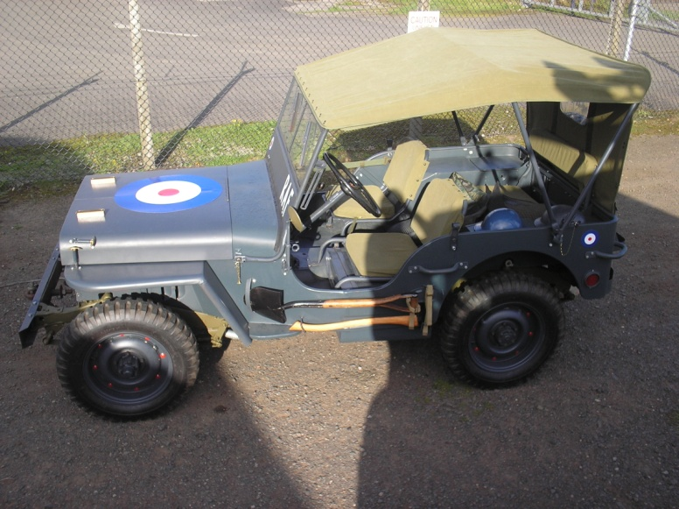
There are many “True” stories about how the Jeep came by its name, but apparently these ubiquitous light reconnaissance vehicles were known as “Jeeps” the moment they entered service.

This Heroic little Truck gave excellent service to all Allied Forces on All Fronts in every theatre of war.

