Stourbridge Pre-War Car Club





**www.stourbridgeprewarcc.com**

**April 2023**

**Committee**

President Mac Grimmett 01384 279497

Chairman John Lees Senior 01746716216

Vice Chairman David Finch 01746716459

Treasurer Alan Bateman 01384 370492

Secretary Howard Whatmough 01527870089

Librarian / Historian Rod Jones 01384 79899

Membership Secretary Geoff Salminen 0121 427 2189

Newsletter Editor

Website Editor Chris Read 01562 882232

Diary Secretary Iris Gillett 01215592374

Facebook Liz Biggs N/A



**Stourbridge Pre War and Classic Car Club**

**Minutes of meeting held on the 13th April 2023**

**1)Apologies: -** Eric Masters, Yvonne and Howard Whatmough, Rod Jones, Ian Hankinson, Richard Freak and Steve Low.

1. **Matters Arising**: - There was no matters arising from March or April’s meeting.
2. **Agreed Minutes: -** February AGM Proposed John Smith, Seconded Pete Fox.

February Minutes Proposed Kevin Birch, Seconded Arthur Wood.

1. **Chairman’s Report: -** The Chairman presented Kevin with a small gift from the Club in appreciation of his hard work as past chairman. The members present gave him a round of applause.

John Less expressed his concern that the Club was stagnating a little with regard to lack of events. In particular, bearing in mind the increasing average of members that events needed to be staged in daylight hours. Primarily to assist the old cars and even the older drivers.

He reported concerns about lack of ideas coming from members with a small core of the membership seeming to be responsible for suggestions and following up on propositions. Discussion from the floor saw this point, but it was pointed outby Alan Jones, that this was the case with all organisations similar to ours.

John left the conversation open for discussion at future meetings.

There had been a somewhat unpleasant situation in which a member had been invited to resign from the membership, John had lead this meeting. Without too much un-necessary detail as to why the Committee had come to the unanimous decision to action this. There has been no further communication from the party to contra his action, further legislative measures for censure were deemed ended.

**5) Vice Chair’s Report: -** standing in for Secretary.

1. **Secretary’s Report: -** In absentia Howard had asked that Kevin was thanked for his work in promoting the Club presence at the N.E.C. Show. A great success with cars from Geoff Bethel, Chris Lees and John Bates on display. Thanks also to all members staffing the stand over the three days.

Drive It Day this year is organised to be on the 23rd of April2023 and will commence with breakfast at the Island Pool from 8.30 am until 9.30 am. Please inform Howard if you are taking breakfast for venue numbers.

The route instructions will be distributed and drive off will commence immediately breakfast is ended.

**Concours** Please can all cup holders return their trophies in a clean condition A.S.P. If necessary, bring them to the concourse cleaned ready for re-presentation. Any identifying stickers to be left on please.

Yvonne has to apologise to members as her email has been compromised and when safe we will be informed as to resumption of the status quo.

1. **Treasurer’s Report: -**The following report is for 2 months due to cancellation of the March meeting.

**Income this month**

Membership £1310.

**Expenses: -**

Skittles night £536.97

NEC hospitality £42.25

**Accounts: -**

Savings £3014.68

Current Account £1479.30

Cash in hand £189.05

There was no raffle at February’s A.G.M.

1. **Newsletter: -** The meeting was informed that Steve Butler was not too well and consequently could not see his way to keeping the newsletter going. Chris Read has spoken to him and offered the Club’s thanks for all his work. The meeting felt a minute would be appropriate to record our thanks and to wish him well as an ordinary member.

The Chairman asked for volunteers to take on the position without direct positive response.

1. **Webmaster: -** Chris informed the meeting that the Website was up to date and running well. From the floor it was asked if the Website could encompass the newsletter, especially as so few members took a hard copy.

Perhaps news items could be incorporated and if personal or confidential to the Club, within the encrypted pages.

Members would have to be willing to support this to avoid extra work for the Webmaster.

Further discussion to follow.

1. **Events: - See** end of minutes.
2. **Membership: -** Geoff reported nothing new in membership.
3. **Facebook**
4. **Historian/Librarian: -** Previous apologies from Rod
5. **A.O.B.: -** Nothing was brought up.
6. **Mid-Month lunch: -** Wednesday 19th of April at the Royal Oak Alverly. WV16 6AB 12 n00n, no need to book.
7. **Raffle: -** Our own Iris won.

Meeting closed at 21.25

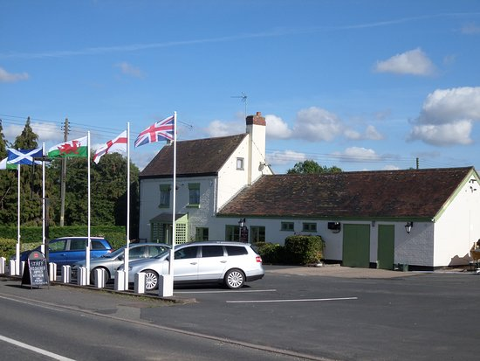***Mid-month Lunch***

***The Royal Oak,***

***Alverly.***

***WV16 6BA***

***Booked from 12noon. It is a carvery so no need to pr-order.***

Please note a new day.

Ian Hankinson is now booking these lunch trips.

Phone 01952529252 07710746910

Email [hank61@virginmedia.com](mailto:hank61@virginmedia.com)

Events

April

19th Mid-month lunch The Royal Oak, Alverly

23rd Drive It Day meeting at The Island Pool

24th Bowling Green Stoke Prior from 6pm look at their website.

May

7th Great Alne Coronation celebration, further details from John Bates 01527458278

11th Monthly meeting

13th RES’s Enville 10am to 12noon

17th Mid-month lunch The Bulls Head, Chelmarsh more info to come (MITC)

28th Bridgnorth Carnival, please contact Dave Finch for further details

31st Black Pig Company Alcester Road, Inkberrow

June

7th picnic at Alex and Peggy’s

8th Monthly meeting

10th Golden Valley Classic show. Bookings Samantha 07879628235 vintageandcountryfair.co.uk

17th Concourse at Arley Arboretum

21st Mid-month lunch Swan Blakedown (MITC)

24th-25th !940’s SVR see their website

26th Bowling Green

July

13th Monthly meeting

15th Redditch town centre, form attached to minutes

19th Picnic

24th Bowling Green

August

2nd Picnic

6th Trimpley

10th Monthly meeting

16th Mid-month lunch Dog at Worfield (MITC)

26th Gloucester Retro Gathering, you need to book in

28th Pershore Plum Festival, need to book in

28th Arley vintage festival

28th Bowling Green

September

2nd Peopleton, you need to book in

6th Picnic

10th Dorridge Festival more info from John Bates 01527458278

14th Monthly meeting

16th-17th Stoke Prior Steam Rally, application included in these minutes

25th Bowling Green

A big thank you to Dave finch for standing in at the eleventh hour for Howard and myself at the monthly meeting, you did a great job.

